**Ganpat University**

**Faculty of Engineering & Technology**

**Computer Science & Engineering**

**(2CSE204) Basics of Operating System and Shell Scripting**

***Name:- Dwij Vatsal Desai***

***Sem:- 2***

***Sub: - BOSS***

***Enrollment No.:- 23162121027***

***Prac:- 9***

***Date:- 14/4/2024***

**Practical 9**

1. Configure one machine (servera) in such a way that if the public key of a remote user is modified then login is restricted.

***Command:-***

**In servera:-**

ssh-keygen (Phase: dwij)

***Image:-***

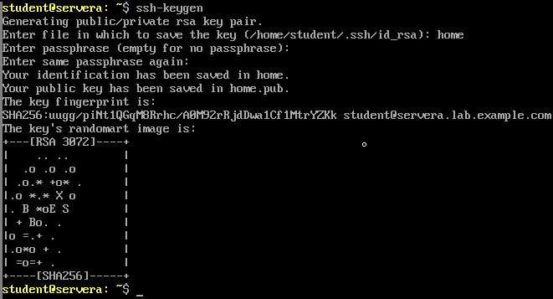

**Now in serverb:-**

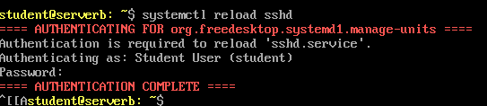

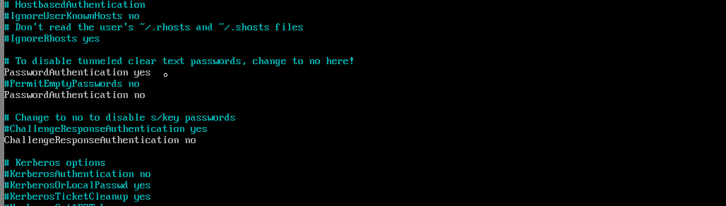

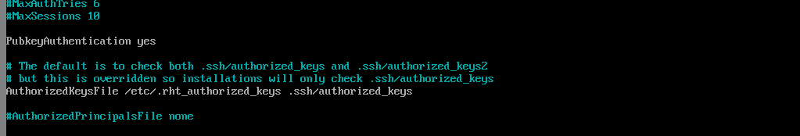

1. Enable password-less authentication for the user to access remote server.

***Command:-***

Server A

ssh-keygen

ssh-copy-id student@serverb

ssh student@serverb

***Image:-***

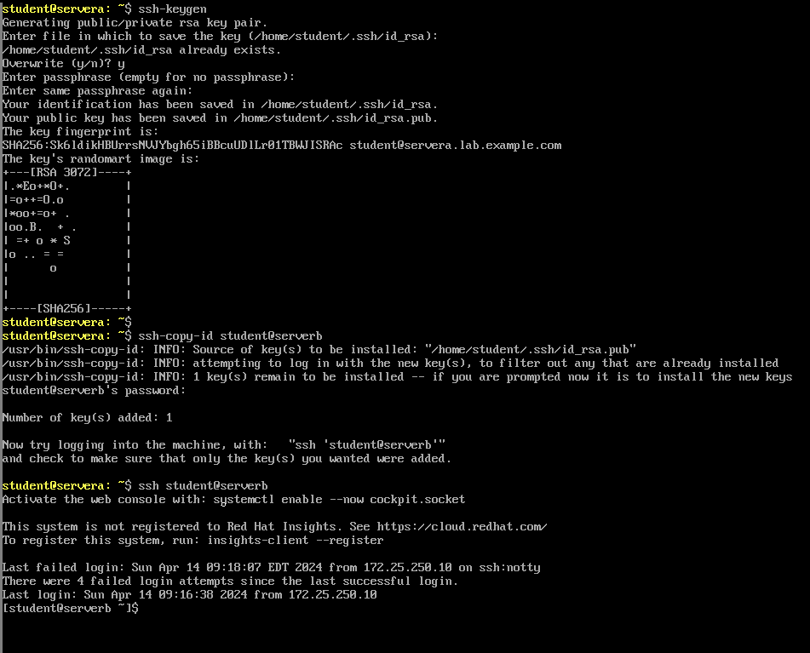

1. On serverb, restrict root login to any system.

***Command:-***

***Image:-***